For Immediate Release
July 19, 2016

Experimental Outfit GUS MCARTHUR Streaming Debut Studio EP
Chapter 1: Hysterics From The Book Of Gus via Decibel Magazine’s “Deciblog”
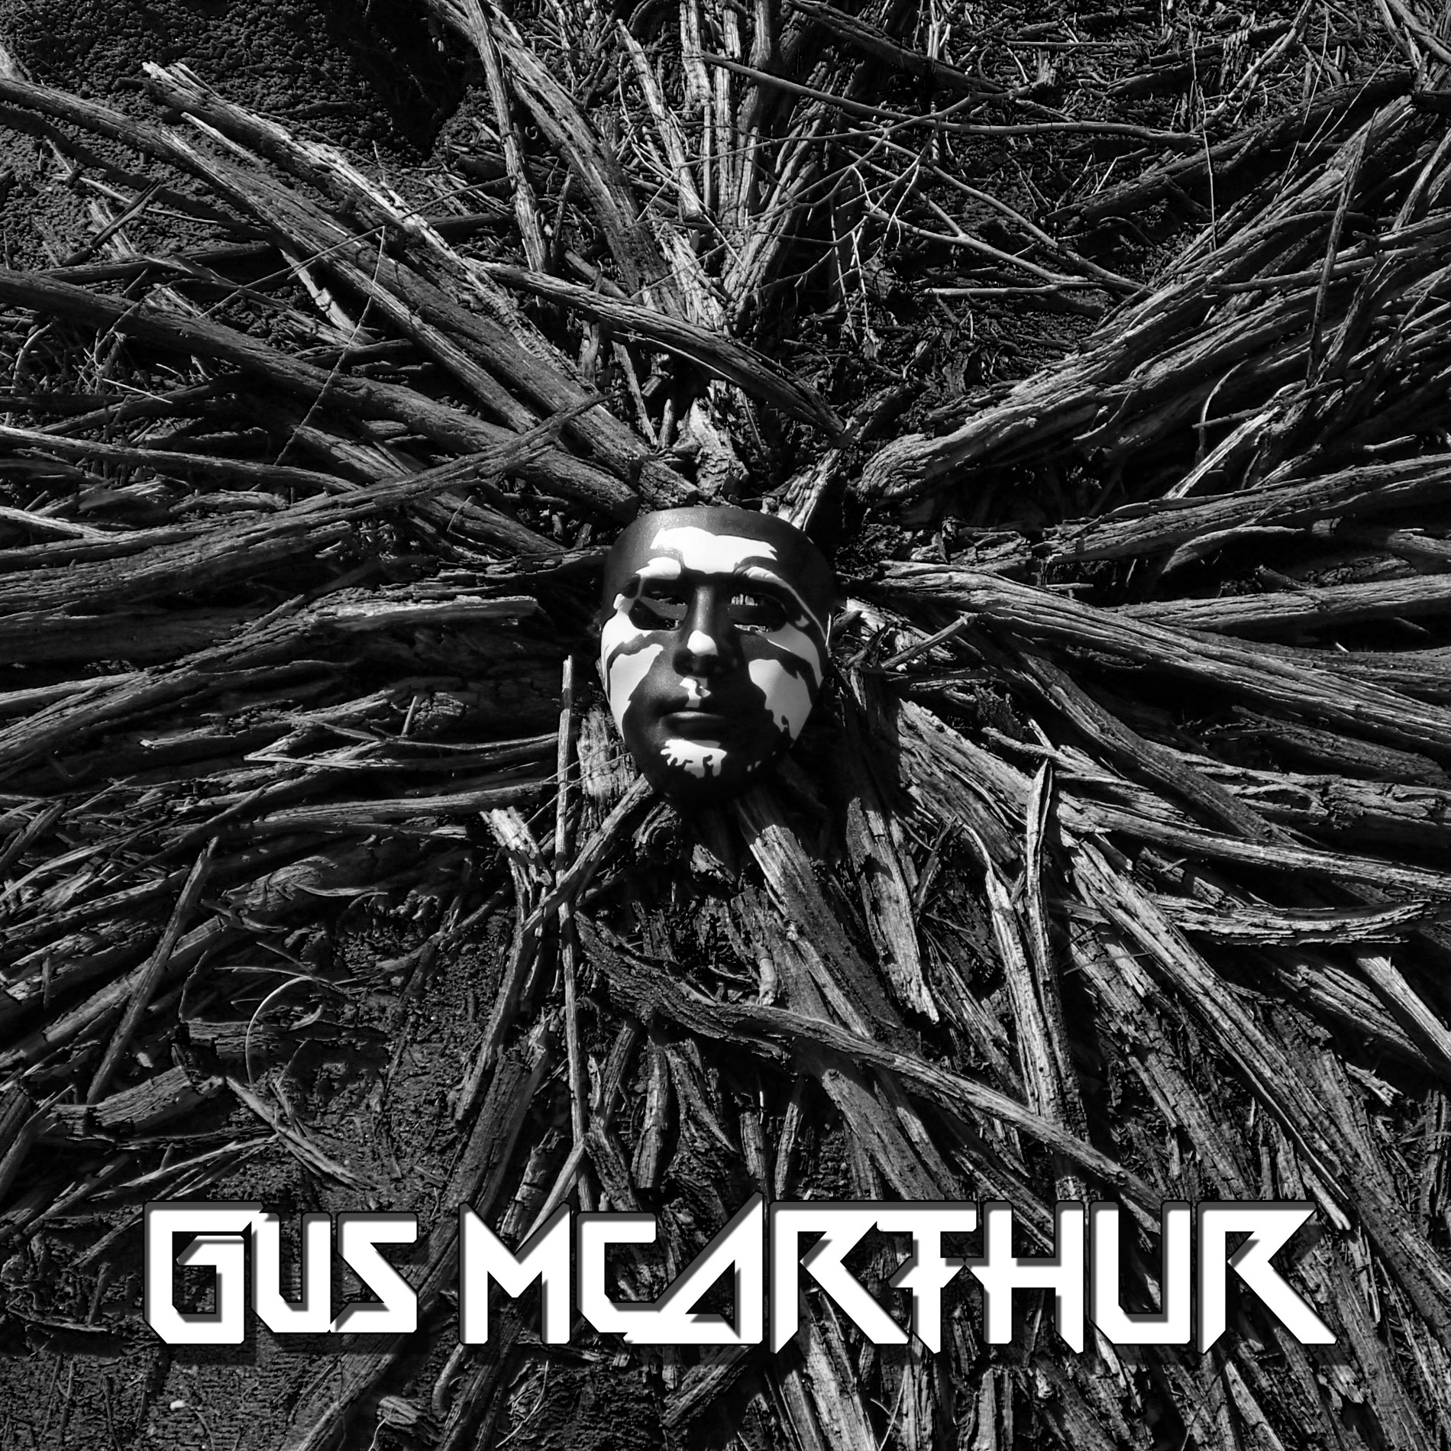

Available This Friday July 22nd!

Experimental outfit GUS MCARTHUR is set to release their first ever studio EP, Chapter 1: Hysterics From The Book of Gus this Friday! This self-released EP examines modern day Hysteric culture and beliefs. Chapter 1 will be the first in a three-part series, which will ultimately be one full album.
In anticipation of the EP’s impending release, GUS MCARTHUR has teamed up with Decibel Magazine’s “Deciblog” for a full EP stream. Check out Chapter 1: Hysterics From The Book of Gus courtesy of Decibel Magazine. HERE.
The EP is available for pre-order HERE.
The band is the collaborative effort of two brothers, Honan and Gordon, each from a different musical background. In late 2014, the brothers decided to combine their unique styles into a blend of their genres and influences. The result is an EP of all new music unlike any other. It is audacious, fast, hard hitting, and lyrical all at the same time.
GUS MCARTHUR was created to expand spectrums of music that currently existed in one form, generating innovative content of multiple genres, ultimately creating a new version of music. Each voice inside the head of GUS MCARTHUR speaks from a different musical background and passion. Their unique sound was forged from necessity to satisfy the void created in their souls by FM radio.
Members:
Honan “The Destroyer” McArthur – Guitars
Gordon “The Hater” – Vocals
Johnson “The Z” Zhang - Drums
Track Listing:
- The Way to Go
- He Who Swallowed God
- Harlot’s Kiss
- Final Prayer
For More Info Visit:
Website: http://www.gusmcarthur.com/
Facebook: https://www.facebook.com/GusMcArthurOfficial/
Instagram: https://www.instagram.com/gusmcarthur/
Youtube: http://www.youtube.com/c/GusmcarthurTV
Twitter: https://twitter.com/GusMcArthur

